Donate Books for Class Libraries
New or gently used books of all genres including: graphic novels, nonfiction, fiction, phonics, easy readers, and chapter books.
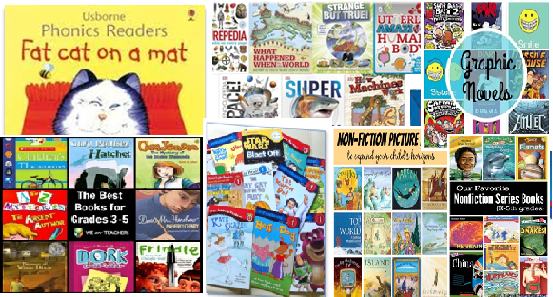
Volunteer hours available for marking the lexile and grade level of the donated books.
For details contact your media specialist or visit her Weebly page at
http://fa-huff.weebly.com
Bolt Bucks are available to students who donate books.
Contact Ms. Huff at: huff.robyn@franklin-academy.org
