Labeling Books Instruction Sheet
- Go to http://www.scholastic.com/bookwizard/.
- Type the book title and click find books. If the book is in a series and has a subtitle, it may be easier to use that.
- Find the book that you searched for and click the title. Make sure that you have selected the right book; some have multiple versions.
- Look on the left side of the screen for the lexile and guided reading level.
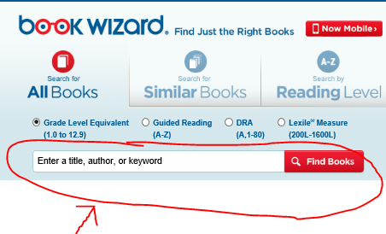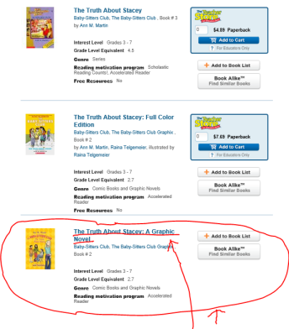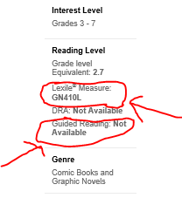
- If the website above does not list the lexile, you may be able to find it at https://lexile.com/.
- After searching for your book, select the book’s title. The green circle at the right will have the lexile.
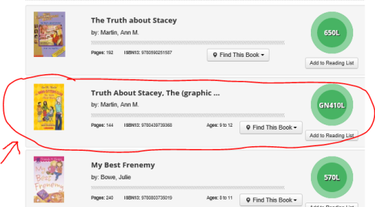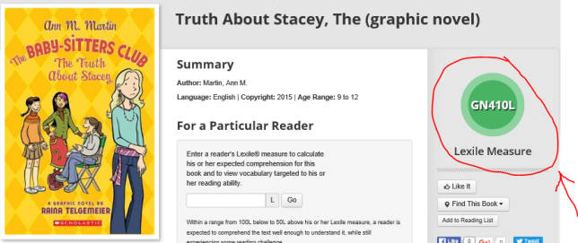
- To find the Accelerated Reader information, go to http://www.arbookfind.com/, and search for the title or subtitle in the quick search tab.
- Look for the AR level and points. They will be on the website as BL for the AR level and AR pts for points. Use this website for AR level and points only. Do not use other websites for the AR level and points because they may not be accurate.
