The Great Book Stack Challenge

Dear Parents and Incoming Kindergarten & First Grade Students,

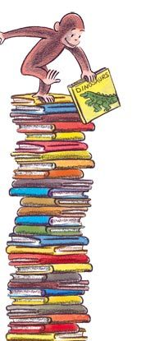This year for our summer reading project each child will participate in an independent reading challenge. It is a great way for students to expand into different genres and have fun reading this summer.

Read the correct number of books from each category below or have someone read to you. Once you’ve finished each book, (you don’t have to do them in order) check off the box and then fill in and color a book spine on your stack! Choose your favorite fiction book and create your paper bag puppet based on the main character.

Bring your book stack and puppet in at the beginning of next year to show off all of your reading! Have fun!

\*\*\*\*\*\*\*\*\*\*\*\*\*\*\*\*\*\*\*\*\*\*\*\*\*\*\*\*

Three picture books

Two informational books on the same topic

One book of your choice

All of the summer reading challenge documents can be found on the Franklin Academy website or on

Ms. Huff’s Weebly page.

<http://fa-huff.weebly.com>